**Task 4:-**

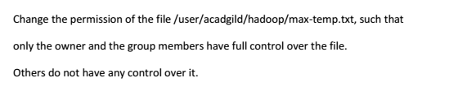

**Solution:-**

The permissions can be changed in HDFS by **chmod** command.

There are 3 types of users for any files or directories. They are

* Owner (represented by **u**)
* Group (represented by **g)**
* Other users (represented by o)

There are 3 types of permissions that can be added to these above 3 mentioned users using **chmod** command. They are

* Read (represented by **r**)
* Write((represented by **w**)
* Execute(represented by **x)**

From the below screenshot,

* From the first 3 spaces, we can say that **owner** don’t have read and write permissions but it has only execute permission for max-temp.txt.
* From the next 3 spaces, we can say that **group** don’t have read and write permissions but it has only execute permission for max-temp.txt.
* From the next 3 spaces, we can say that **other users** have read,write and execute permission for max-temp.txt.

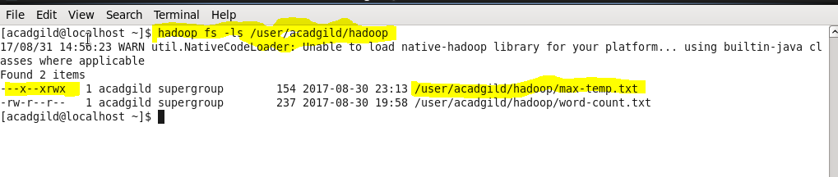

**u+rwx:-**

u+rwx denotes that read,write and execute permissions will be added for owner.

**g+rwx:-**

g+rwx denotes that read,write and execute permissions will be added for group.

**o-rwx:-**

o-rwx denotes that read,write,execute permissions are removed for other users.

After adding permissions to owner(u) and group(g) and removing permissions to other users for max-temp.txt using **chmod** command as shown in the below screenshot.

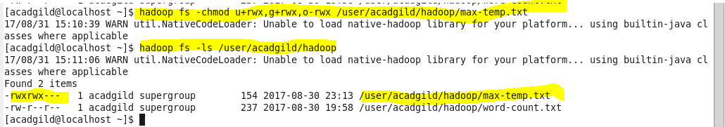

In the above screenshot, **first rwx in rwxrwx**--- denotes that owner have read,write and execute permission, **second rwx in rwxrwx---** denotes that group have read, write and execute permission. **--- in rwxrwx---** denotes that other users don’t have any permissions such as read, write, execute.